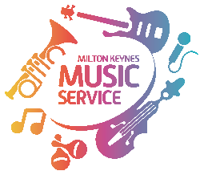**OVERVIEW**

**African Drumming**

**During this project the children will:**

* Be able to pitch match using Kodaly handsigns (soh, me, lah, low doh, high doh, re)
* Sing authentic African songs as Call and Response songs
* Sing authentic African songs in parts, including in canon and with an ostinato
* Be able to describe rhythms in terms of walk, jogging, stride values
* Learn to play the bass and rim tones on the djembe
* Be able to combine different rhythmic parts using djembes, in groups
* Help devise and then play a rhythmic piece that uses unison, question and answer, combined rhythms

**Some children will be able to progress further in order to: (1/exceeding)**

* Be the leader in pitch matching games using Kodaly handsigns soh, me, lah, low doh, high doh, re
* Sing the chosen songs confidently alone or be able to lead a group
* Use the time values walk, jogging, stride to describe the rhythmic parts
* Be able to accurately and effectively play the bass and rim tones with ease
* Be able to lead others in a multi part song or rhythmic piece

**Some children will: (2/achieving)**

* Be able to pitch match accurately using Kodaly handsigns soh, me, lah, low doh, high doh, re
* Sing the chosen songs clearly, tunefully and confidently in groups
* Identify the time values walk, jogging, stride
* Be able to copy the bass and rim tones with a clear difference in tone between them
* Be able to participate in a muli part song or rhythmic piece

**Some children will need help in order to: (3/emerging)**

* Be able to pitch match accurately using Kodaly handsigns soh, me, lah, low doh, high doh, re
* Sing the chosen songs tunefully in a group
* Be able to copy time values walk, jogging, stride but not be able to identify them in a given rhythm
* Move their hand to the appropriate area of the drum, but not be able to make a clear difference between bass and rim tones
* Be able to participate in a muti part song or rhythmic piece if there is a strong leader to follow